

Credit Hours System

CMPN 401 - ADB

Cairo University Faculty of Engineering



ADB PHASE 1 DELIVERY



|  |  |
| --- | --- |
| Ahmed Mohamed Ismail | 1180501 |
| Mostafa Ashraf Ahmed | 1180406 |
| Moaz Mohamed ElSherbini | 1180528 |
| Nader Youhanna Khalil | 1180477 |

# Describe the existing system as well as hardware characteristics.

## Operating System

## CPU and RAM

## Hard Disk

# ER Diagram

# Database Report

|  |  |  |  |  |  |  |
| --- | --- | --- | --- | --- | --- | --- |
| Table Name | Row Count | Main Key | Indexes | FK | Identity Column | Max Row Size (Bytes) |
| Employee | 1M | Yes | 1 | 2 | Yes | 71 |
| Department | 1M | Yes | 1 | 1 | Yes | 19 |
| Project | 1M | Yes | 1 | 1 | Yes | 38 |
| Works_On | 1M | No | 1 | 2 | No | 12 |
| Department_Location | 1M | No | 1 | 1 | No | 19 |
| Dependent | 1M | No | 1 | 1 | No | 38 |

# NOSQL

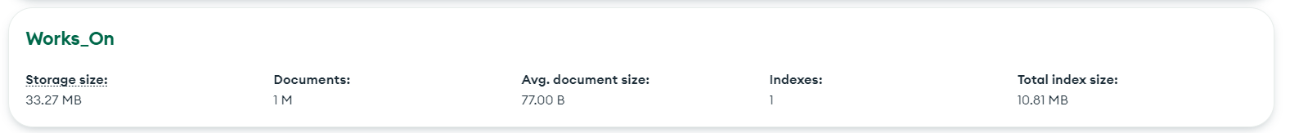

# MongoDB Collections

## Employee

## Department

## Department_Location

## Project

## Dependent

## Works_On

